Scottish Museum of Empire, Slavery, Colonialism and Migration

A unique opportunity to work on building a new Museum and
Anti-Racism Archive

Operations and Finance Coordinator – Job Applicant Pack – September 2026
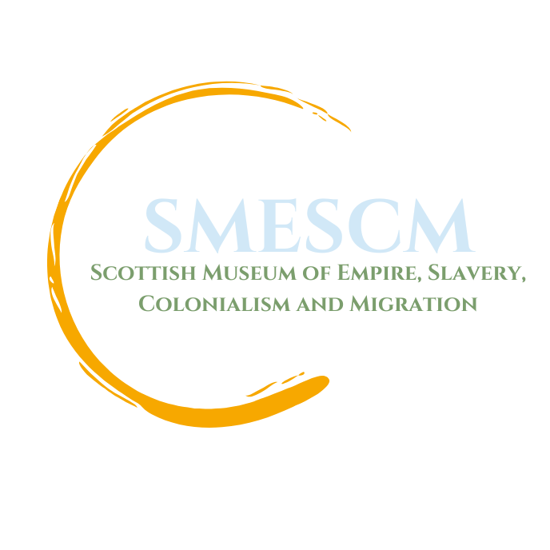

September 2026

The Scottish Museum of Empire, Slavery, Colonialism and Migration¹ is looking for an Operations and Finance Coordinator.
OUR VISION
A Scotland committed to anti-racism that explores and addresses the legacies of Empire, Slavery, Colonialisation and Migration. Through connecting people to our shared histories, we have a platform from which to imagine, name and resource a more equitable and collectively owned future.
In January 2024, the Scottish Government accepted in full the recommendations of the Empire, Slavery and Scotland’s Museums (ESSM) project². The Scottish Museum of Empire, Slavery, Colonialism and Migration has been established to lead on Recommendation 1:
“Scotland should create a dedicated space to address our role in empire, colonialism, and historic slavery. A new organisation should be created to lead this work.”
The Board and Staff will lead on future work relating to a Museum of Empire, Slavery, Colonialism and Migration in Scotland. The other recommendations are being implemented through Museums Galleries Scotland and other organisations. The full set of recommendations are:
1. Scotland should create a dedicated space to address our role in empire, colonialism, and historic slavery. A new organisation should be created to lead this work.
2. Museums should ensure anti-racism is embedded in their workplaces and public spaces.
3. Museums should involve the people of Scotland in shaping their work through co-production, to promote cultural democracy and participation for all.
4. Museums should commit to research, interpret, and share the histories of Scotland’s links to empire, colonialism, and historic slavery.
5. Museums should support efforts to promote and embed race equality and anti-racism in the curricula in a meaningful, effective, and sustainable way.
6. Scottish Government should demonstrate their support for restitution and repatriation of looted or unethically acquired items in Scottish collections.
The Scottish Museum of Empire, Slavery, Colonialism and Migration is an OSCR registered Scottish Charitable Incorporated Organisation (no: SC054537) and has been led by a Board of Trustees, made up of those with a wide variety of anti-racist and museums expertise.
The Scottish Museum of Empire, Slavery, Colonialism and Migration (SMESCM) has hired two Co-lead Coordinators, recruited a new board of trustees, begun developing internal systems and processes, built strong community networks and delivered programming in partnership with other heritage organisations.
We want to continue progressing work on delivering a national museum dedicated to exploring and sharing Scotland’s colonial and imperial histories; an organisation that is essentially anti-racist and decolonial, led by People of Colour, and looking to establish practices that move away from defunct traditional models.
We are now looking for an Operations and Finance Coordinator to oversee all administrative duties for the organisation relating to a period of significant development.
The Operations and Finance Coordinator will work closely with the Museum Director, the Board, and staff team on the priorities outlined in the job description below. Although initial funding has been secured until March 2027, this is a long-term project, with the intention that further funding will be secured.
Applications for the post of Operations and Finance Coordinator are now invited. A job description / person specification is outlined below, along with details of the terms and conditions of employment and how to apply. Applications must be submitted by 12:00 PM (noon) on Wednesday 16 September 2026. Interviews are expected to take place in early October.

Scottish Museum of Empire, Slavery, Colonialism and Migration

A unique opportunity to work on building a new Museum and Anti-Racism Archive

Job Description:

Job Title: Operations and Finance Coordinator

Reports to: Museum Director (Chair of the Board on an interim basis)

Salary: £34,492 p.a. plus generous pension options
(secondment, part-time, flexible working and job-shares considered)

Main Purpose of Job:

The post holder will play a key role in advancing the mission of the Scottish Museum of Empire, Slavery, Colonialism & Migration, focused on promoting antiracism, equality, and social justice.

This dynamic individual will be responsible for the smooth day-to-day running of the organisation and will lead on coordination of all aspects of SMESCM’s infrastructure, financial administration, operations management, acquisition and management of office space and support with coordination of activities. They will support the Board of Trustees through minute taking, meeting management, expenses processing, and other tasks.

The ideal candidate will be passionate about social justice, have excellent organisational and communication skills and possess experience in administrative management or support. Specific museum experience is not required, and full support will be offered for any specialist training needs.

Key Responsibilities:

Administrative and Operational coordination:

- Oversee and support all administrative duties for SMESCM
- Manage and maintain organisation’s IT infrastructure
- Draft, maintain, and update organisational policies as required
- Oversee health and safety policies and any issues related to health and safety, equipment maintenance and repair
- Manage online and paper filing systems
- Ensure that hybrid working arrangements in place lead to the most effective working outcomes, and that they meet the needs of staff and regulatory requirements

Financial Management:

- Undertake overall responsibility for managing, coordinating and administering SMESCM’s finances
- Process and prepare accurate financial reports and analysis, including on expenditure, cash flow, budgeting and the production of monthly management accounts
- Operate online banking systems, including preparing and reporting on banking transactions, maintaining banking records, processing bank payments and preparing bank account reconciliations
- Assist with the annual financial audit and liaise with SMESCM’s auditors and funders as required
- Assist with the production of funding applications and tenders for contracted work
- Oversee and maintain services and contracts, including insurances, leases, office equipment, cleaning, etc.
- Undertake continuous reviews (and improvements) of SMESCM’s finance policies and procedures ensuring that they are effective and efficient, and that they conform to the necessary regulatory and funders’ requirements.

Communications support:

- Support on producing engaging content, such as blog posts, press releases, social media posts, and newsletters.
- Support on collaboration with BME communities, heritage organisations, and individuals to create multimedia content, including videos and graphics that support campaign goals.
- Use communication channels, including social media, email, public forums, and community outreach to amplify campaign and impact

Fundraising Support:

- Collaborate with colleagues and the board to pursue funding opportunities that support campaign initiatives

Other:

- Provide direct executive assistance to the Museum Director, the Chair, and Board of Trustees in the management and delivery of SMESCM’s strategic priorities
- Support staff team with related duties and tasks
- Work collaboratively across the organisation, including covering duties of other staff as required
- Utilise opportunities to publicise SMESCM’s work and objectives, including by regularly contributing to SMESCM’s website and social media presence
- Coordinate and communicate with SMESCM’s network of allies and partners in the social justice and antiracism community
- Undertake other duties as required for the successful implementation of SMESCM’s objectives and values

This job description does not represent an exhaustive list of responsibilities and tasks but indicates the main areas of work required from the post holder. Overall, we require the postholder to work with the Board to deliver on our overall vision and to ensure the successful functioning of the organisation.

Person Specification

Key Requirement
- A desire and ability to make a real improvement to anti-racism and racial equality issues in Scotland

Qualifications
- Degree level qualification or equivalent work experience (which can include voluntary work)

Skills and Knowledge
Essential
- Knowledge of equality and human rights issues, particularly regarding race and racism
- Excellent literacy and numeracy skills
- Excellent IT skills including Microsoft Office
- Excellent oral and written communication skills, including an ability to engage with a range of audiences
Desirable:
- Knowledge of charity governance and requirements.

Experience
Essential
- Understanding of racialisation and how racism manifests in Scotland
- Previous administrative experience and knowledge of office and organisational management systems and procedures
- Previous experience of supporting a charity in developing new systems and procedures
Desirable:
- Previous experience of working with a new organisation

Competencies
- Strong interpersonal competency, including an ability to build and maintain excellent working relationships at all levels
- Strong problem-solving skills
- High level of accuracy and consistent attention to detail
- Ability to work under pressure, on own initiative, and to prioritise tasks
- Ability to work independently and to exercise initiative and judgement
- Ability to monitor and evaluate own work
- Willingness to work flexibly, and to contribute to the overall team effort

Terms and Conditions of Employment
- Salary: £34,492 per annum
- Line managed by Museum Director (Chair of the Board on an interim basis)
- Hours: 35 hours per week (if full-time) (secondment, part-time, flexible working and job-shares considered)
- Holiday entitlement: 40 days - 25 days annual leave and 15 days public holidays
- Pension: 8% Employer Contribution to the NEST Pension Scheme
- Working arrangements: A hybrid (home/office) working system will operate, along with flexible working arrangements, although it is expected that three days per week would be office based, likely to be in Glasgow. Travel may be required across Scotland
- Final Terms and Conditions can be agreed at the point of job offer.

How to Apply

To apply for this role, please email your tailored CV and supporting statement (of no more than two pages) outlining your suitability to jatin.haria@empiremuseum.scot by 12 PM (noon) on Wednesday 16 September.
Your covering letter should specifically relate to the key issues outlined in the person specification and job description. The diversity monitoring form (available here) should also be completed.
Late applications will not be considered. Due to the anticipated volume of applicants, we will not be able to give feedback on applications which do not progress to interview stage.
This role is supported by Scottish Government funding.

The Scottish Museum of Empire, Slavery, Colonialism and Migration

